**Anudip Foundation – AJP Lab 1**

**1.Multiplication Table**

**Program:**

import java.util.Scanner;

public class Multiplication{

public static void main(String[] args) {

Scanner sc = new Scanner(System.in);

System.out.print("Enter a number: ");

int num = sc.nextInt();

System.out.println("Multiplication Table of " + num + ":");

for(int i = 1; i <= 10; i++) {

System.out.println(num + " x " + i + " = " + (num * i));

}

}

}

**Output:**

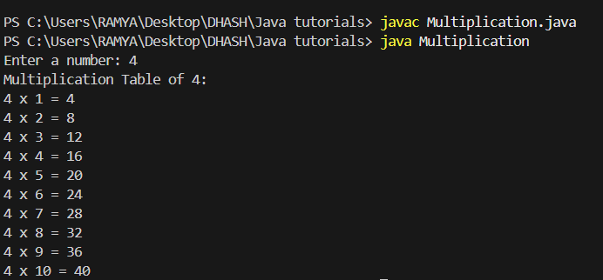

**2. Reverse a Number**

**Program:**

public class reverse {

    public static void main(String[] args) {

        int num = 1234, reversed = 0;

        while(num != 0) {

            int digit = num % 10;

            reversed = reversed * 10 + digit;

            num /= 10;

        }

        System.out.println("Reversed Number: " + reversed);

    }

}

**Output:**

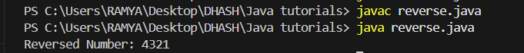

**3. Simple Calculator (Addition, Subtraction, Multiplication, Division)**

**Program:**

import java.util.Scanner;

public class Calculator {

public static void main(String[] args) {

Scanner sc = new Scanner(System.in);

System.out.print("Enter first number: ");

double num1 = sc.nextDouble();

System.out.print("Enter second number: ");

double num2 = sc.nextDouble();

System.out.print("Enter operator (+, -, *, /): ");

char operator = sc.next().charAt(0);

double result = 0;

switch(operator) {

case '+':

result = num1 + num2;

break;

case '-':

result = num1 - num2;

break;

case '*':

result = num1 * num2;

break;

case '/':

if(num2 != 0)

result = num1 / num2;

else

System.out.println("Cannot divide by zero.");

break;

default:

System.out.println("Invalid operator.");

return;

}

System.out.println("Result: " + result);

}

}

**Output:**

